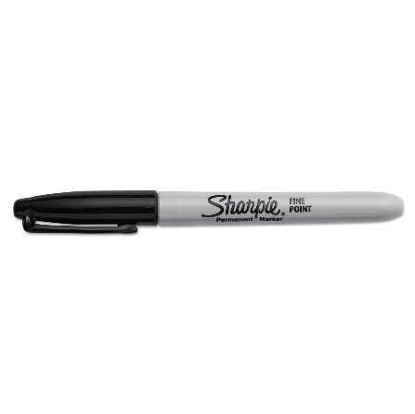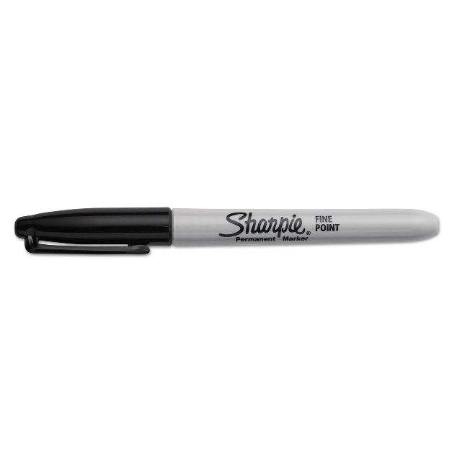

**Do *Not* Write on or Stick Items to Linen**

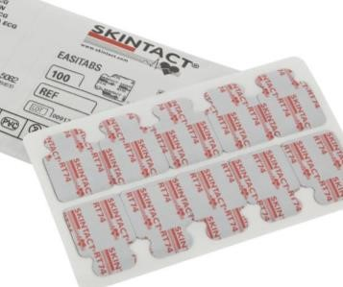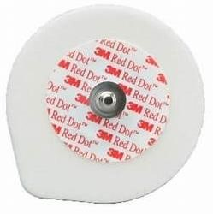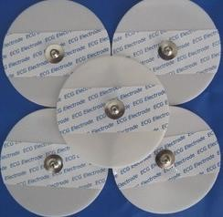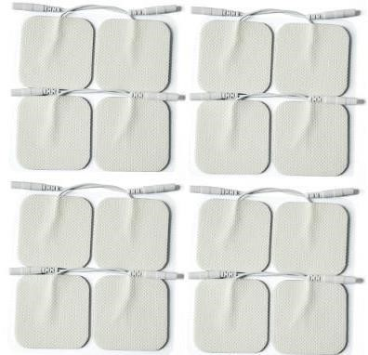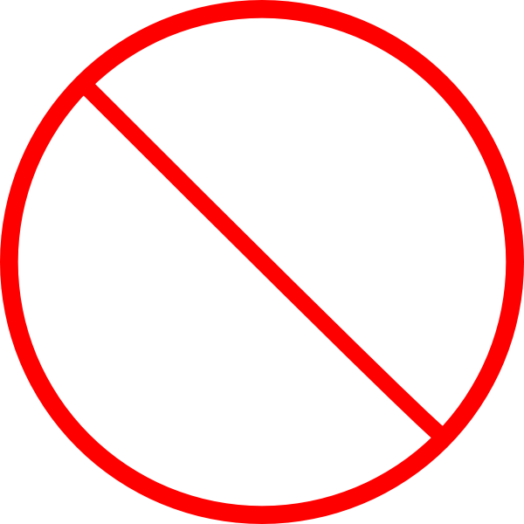

Sincerely,

**The HCSA Team**

Sharpies, Sticky Leads, Tape & Glue ***permanently destroy*** linen in the wash process, please do **not** stick anything to the linen. This is costly to the hospitals in replacement linen costs.

We had to discard 70 sheets in one day because of damage.